Unit 3 Study Guide Name _________________

Things you should know…
Slope formula: m = Slope intercept form:

Parallel lines have _____________ slopes. Perpendicular lines have ________________ slopes.

1. Write the equation of a line that is parallel to y = 2x +11 and passes through the point (5, 2).

2. Write the equation of a line passing through (-1, -4) and (5, 2).

3. Write the equation of a line perpendicular to the y-axis and containing the point (-7, 4).

4. The table shows the relationship between total sugar grams and total calories in a selection of soft drinks.
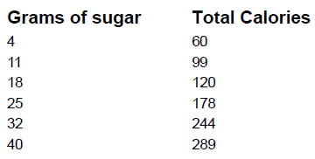
Find the linear regression equation that models this data.

5. Nathaniel is a paperboy. He earns $12 each day he completes a route. He also earns $0.25 for every paper he delivers. Write an equation to model his earning.

6. Stephen compared the y-intercept of the graph of the function f(x) = 4x + -7 to the y-intercept of the graph of the linear function that includes the points in the table below. What is the difference when the y-intercept of f(x) is subtracted from the y-intercept of g(x)?

7. The table below shows the distance a car has traveled. What is the meaning of the slope of the linear model for the data?

8. The table below shows the show size and age of 7 boys. Approximately what percentage of the boys’ ages is more than 1 year different from the age predicted by the line of best fit for the data?
A. 14%

B. 29%

C. 43%

D. 57%

9. The graph of a linear function has a y-intercept of -2 and passes through the point (4, 3). What is the slope of the graph of the function?

10. Write the equation x -3y = 21 in slope intercept form.

11. Write the equation 18 – 2x +6y = 52 in slope intercept form. Identify the slope and y-intercept.

12. A delivery company charges a store one price per box, plus a fee for delivery. What is the delivery fee the company charges?
