Unit 2 Study Guide Name _________________
NC Math 1

For 1-4, solve the inequality and graph your solution.

1. -2 ≤ x – 15 2. -200 > -8(-5 + 6a)

3. 10 - 3x < -22 4. 2x + 2 ≥ -10

5. Eight less than six times a number is greater than 52. What is the lowest possible number?

6. Admission to the Dixie Classic is $8. Each ride costs $1.25. Andrea wants to spend less than $30. How many rides can Andrea ride?

7. You want to buy some coloring books at Target. Coloring books cost $4.25 each. You want to spend no more than $25. How many coloring books can you buy?

8. Is the given relation a function? {(0, 3), (4, 0), (8, 0), (4, -3), (-5, 8)}

9. Is the given relation a function? {(7, 8), (3, 1), (6, 2), (1, 5), (-7, 8)}

10. List the domain for the relation in #9.

11. List the range for the relation in #8.

12. State the domain and range for the graph below.
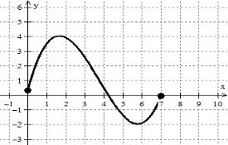

13. State the domain and range for the graph below.
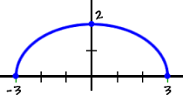

For 14-15, use the following information.
Joe had a summer job that pays $7.00 an hour and he worked between 15 and 35 hours every week. His weekly salary can be modeled by the equation: S = 7h, where S is his weekly salary and h is the number of hours he worked in a week.

14. Describe the appropriate domain and range in this context.

15. What does each value in the ordered pair (20, 140) mean in context of this problem?

For 16- 21, use the functions f(x) = 4x – 3 and g(x) = x² + 3.

16. Find f(h). 17. Find f(2)

18. Find g(-4). 19. Find f(-1) + 5

20. Find g(6) – 4. 21. Find f(-3) + g(2)

